**Database Programming (4203_2)**

**Exercises 8-11**

**Name: Sakshi Jain Student ID: c0753352**

**Instruction: Use Oracle HR sample database to answer exercise 10 and 11.**

Exercise 8 (1.2%)

Create PL/SQL block that has two variables of number datatype, assign numerical values to the two variables, then compare these two numbers, if the first number greater than the second number, display the message “ First Number is greater than Second Number” , if the two numbers are equal, display “Two numbers are equal”, lastly, if the first number less than second number, display “First Number less the Second Number”.

Note: you need to include all the three conditions statements

SET SERVEROUTPUT ON

DECLARE

num1 number;

num2 number;

BEGIN

num1 := &number;

num2 := &number;

DBMS_OUTPUT.PUT_LINE('you entered first number as: ' || num1);

DBMS_OUTPUT.PUT_LINE('you entered second number as: ' || num2);

IF num1 > num2 THEN

DBMS_OUTPUT.PUT_LINE('First number is greater than second number');

ELSIF num1 < num2 THEN

DBMS_OUTPUT.PUT_LINE('First number is less than second number');

ELSE

DBMS_OUTPUT.PUT_LINE('Both numbers are equal');

END IF;

END;

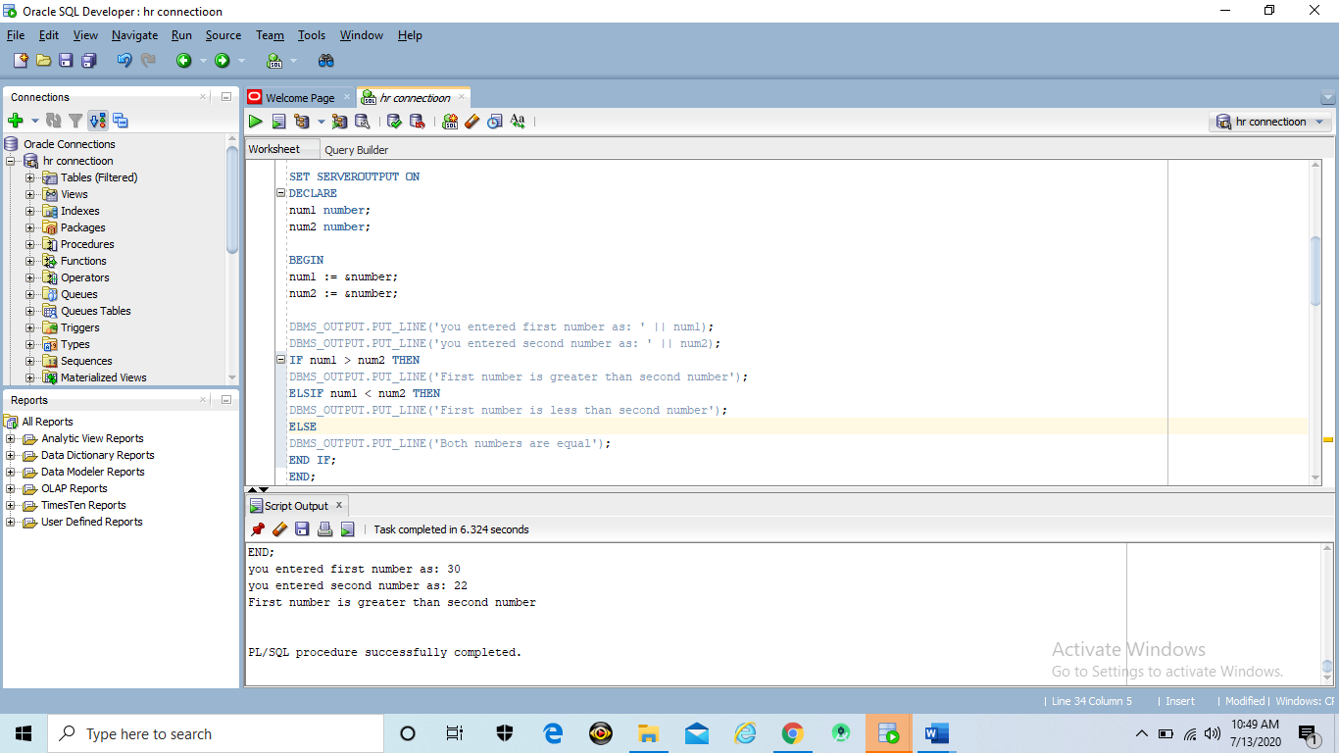

DECLARE

num1 NUMBER(6,0) := 30;

num2 NUMBER(6,0) := 50;

BEGIN

IF num1 > num2 THEN

DBMS_OUTPUT.PUT_LINE('First number is greater than second number');

ELSIF num1 < num2 THEN

DBMS_OUTPUT.PUT_LINE('First number is less than second number');

ELSE

DBMS_OUTPUT.PUT_LINE('Both numbers are equal');

END IF;

END;

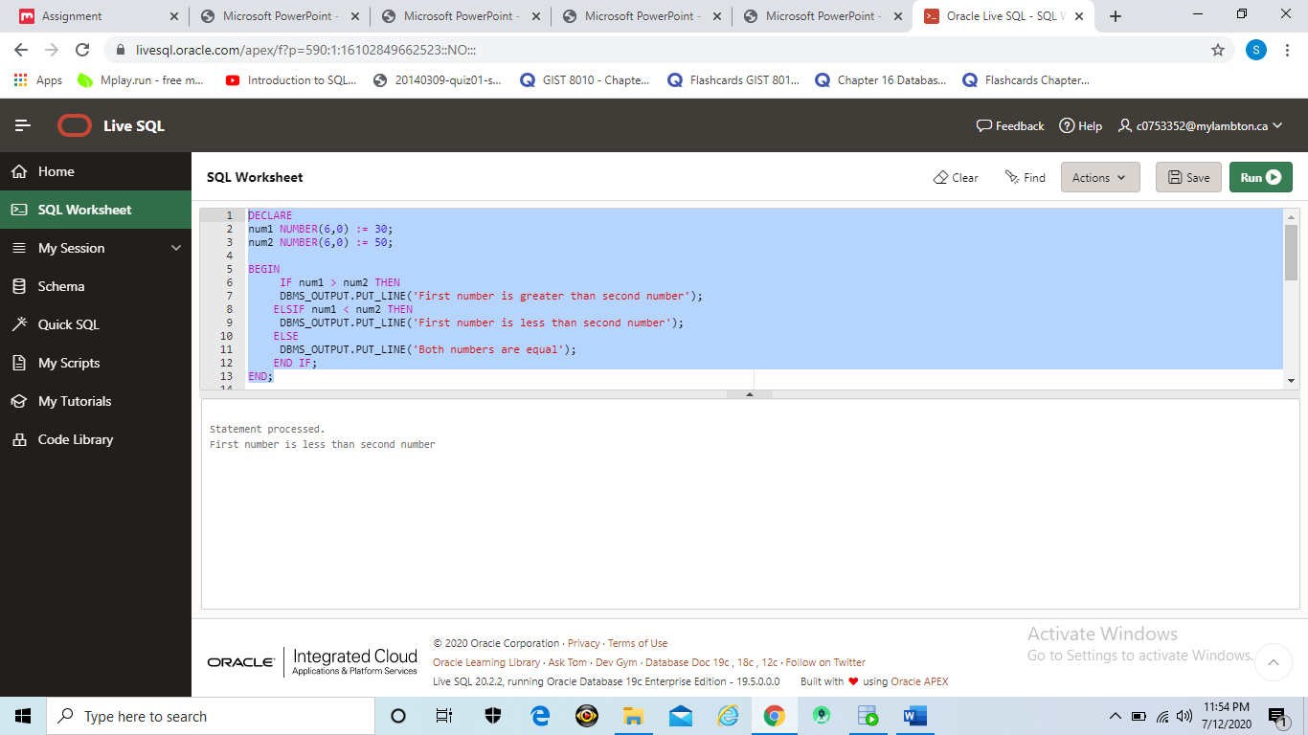

Exercise 9 (1.2%)

**Instruction: Include FULL PAGE screenshot that will display the code and the output on SQL Developer.**

Create PL/SQL blocks that incorporate loops and conditional control structures. This practice tests your understanding of various IF statements and LOOP constructs.

1. Execute the following SQL:

DROP TABLE mails;

CREATE TABLE mails (inbox number);

1. Write a PL/SQL block to insert numbers into the mails table.
2. Insert the numbers 5 through 15, excluding 7 and 9.
3. Commit before the end of the block.
4. Execute a SELECT statement to verify that your PL/SQL block worked.

CREATE TABLE hr.mails(inbox number);

DECLARE

i NUMBER := 5;

BEGIN

LOOP

if i not in(7,9) then

insert into mails values(i);

end if;

i := i+1;

exit when i>15;

end loop;

END;

select * from mails;

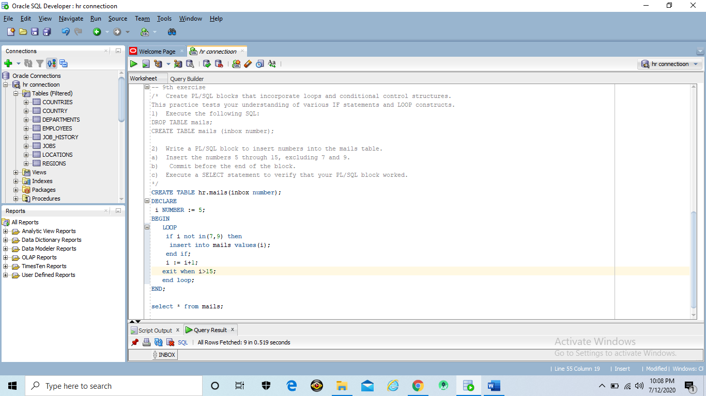

Output

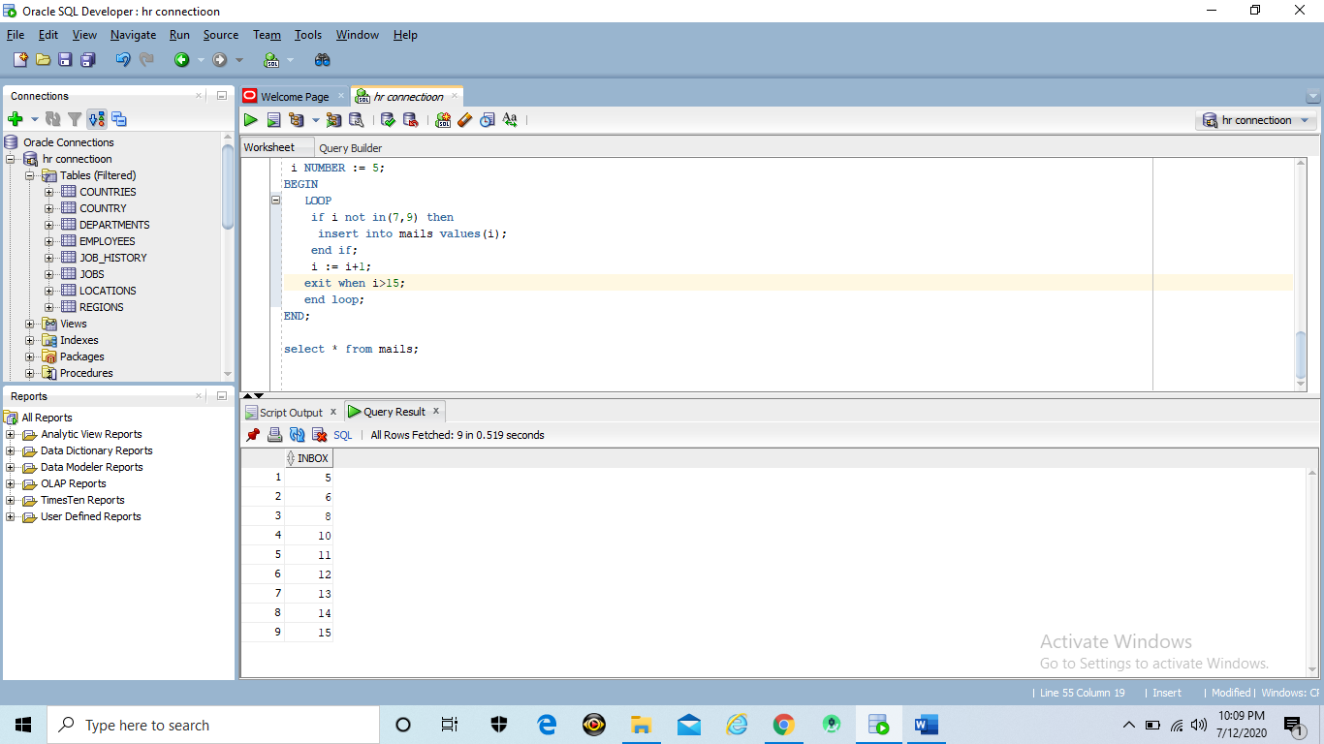

After Commit

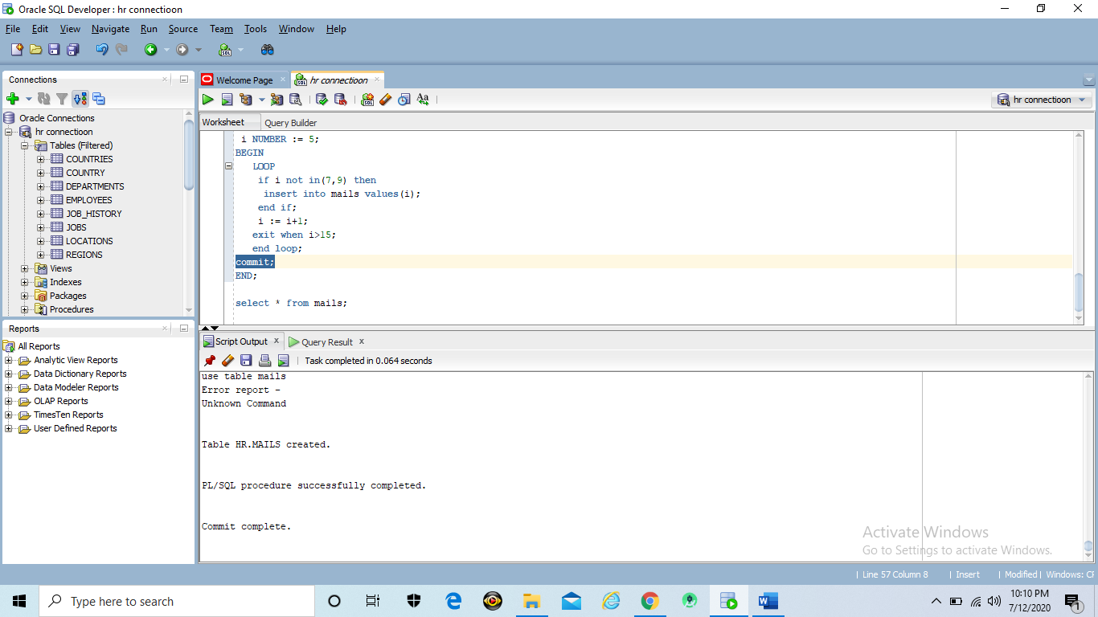

Select statement

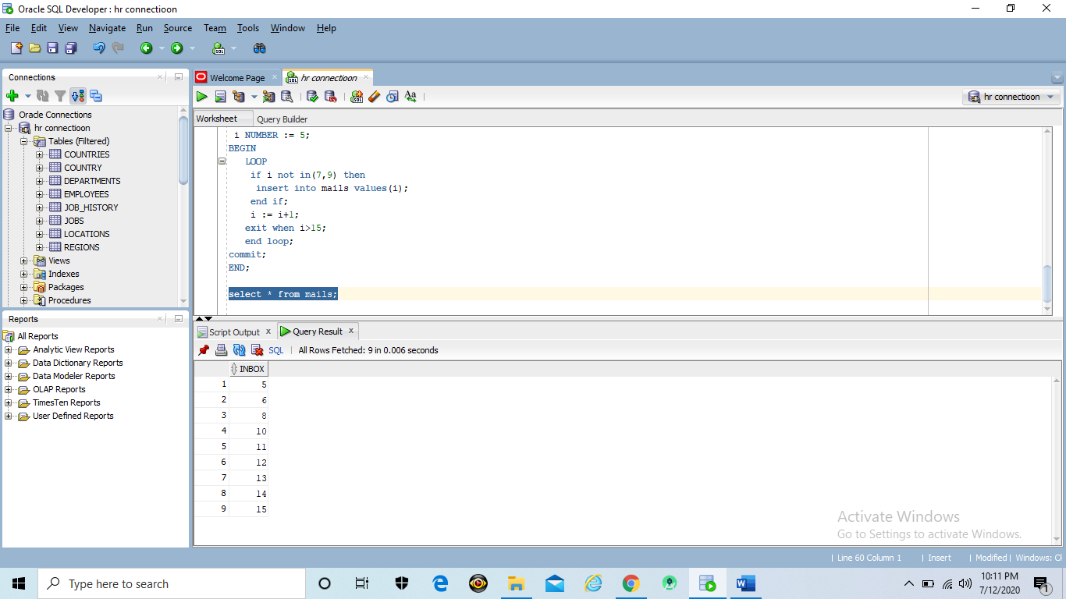

Drop table

drop table mails;

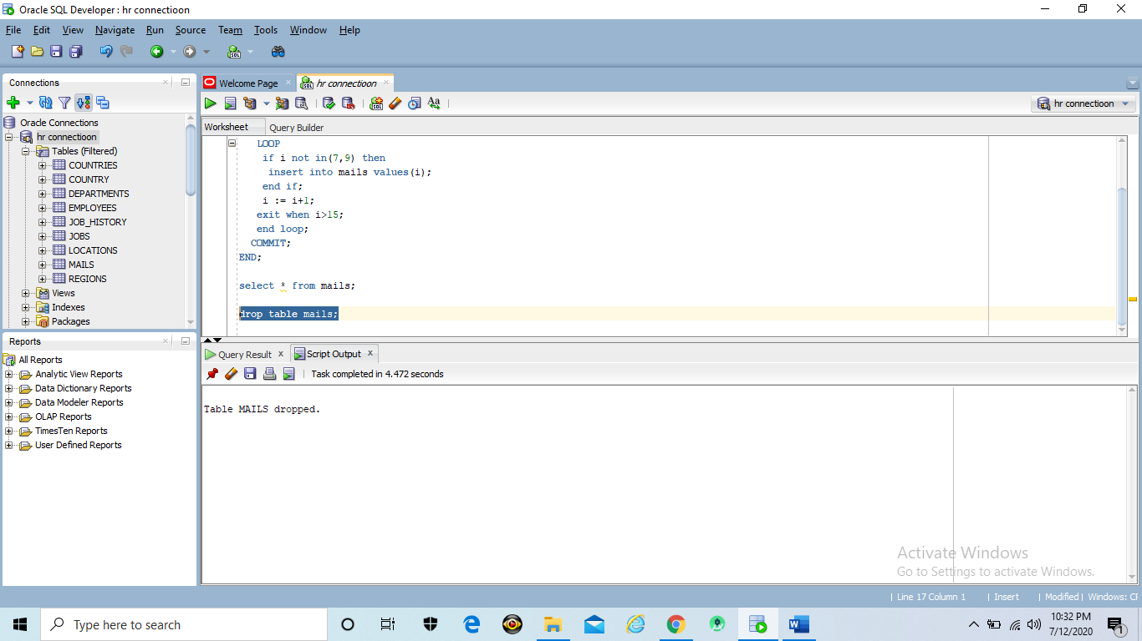

Exercise 10 (1.2%)

**Instruction: Include FULL PAGE screenshot that will display the code and the output on SQL Developer.**

Write a PL/SQL block to print information about a given country.

a) Declare a PL/SQL record based on the structure of the departments table.

b) Declare a variable v_department_id. Assign 60 to v_department_id.

c) In the declarative section, use the %ROWTYPE attribute and declare the v_departments_record variable of type departments.

d) In the executable section, get all the information from the departments table by using v_department_id. Display selected information about the country.

The sample output is as follows

department Id: 60 department Name: IT Manager ID:103 Location_id: 1400

SET SERVEROUTPUT ON

DECLARE

v_department_id NUMBER := 60;

v_departments_record hr.departments%ROWTYPE;

BEGIN

SELECT * INTO v_departments_record

FROM hr.departments

WHERE department_id = v_department_id;

DBMS_OUTPUT.PUT_LINE('Department Id:'||v_departments_record.department_id ||' Department Name:'||v_departments_record.department_name ||' Manager Id:'||v_departments_record.manager_id||' Location Id:'|| v_departments_record.location_id);

END;

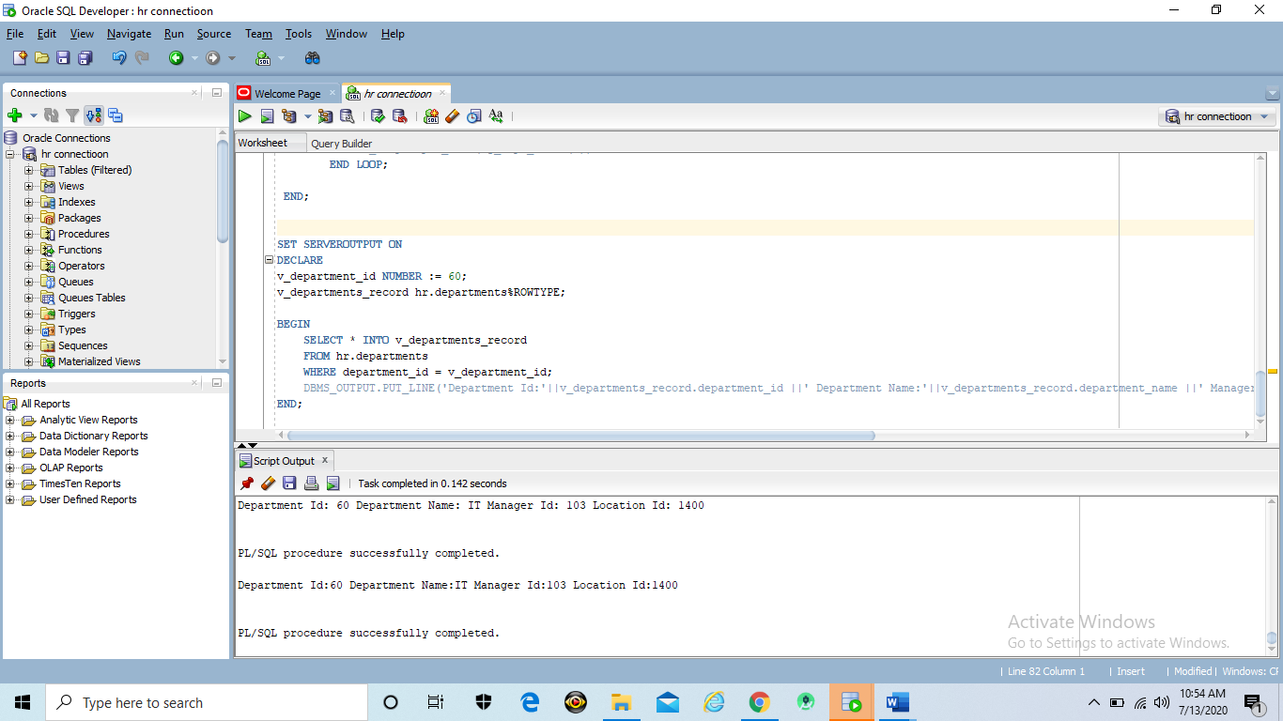

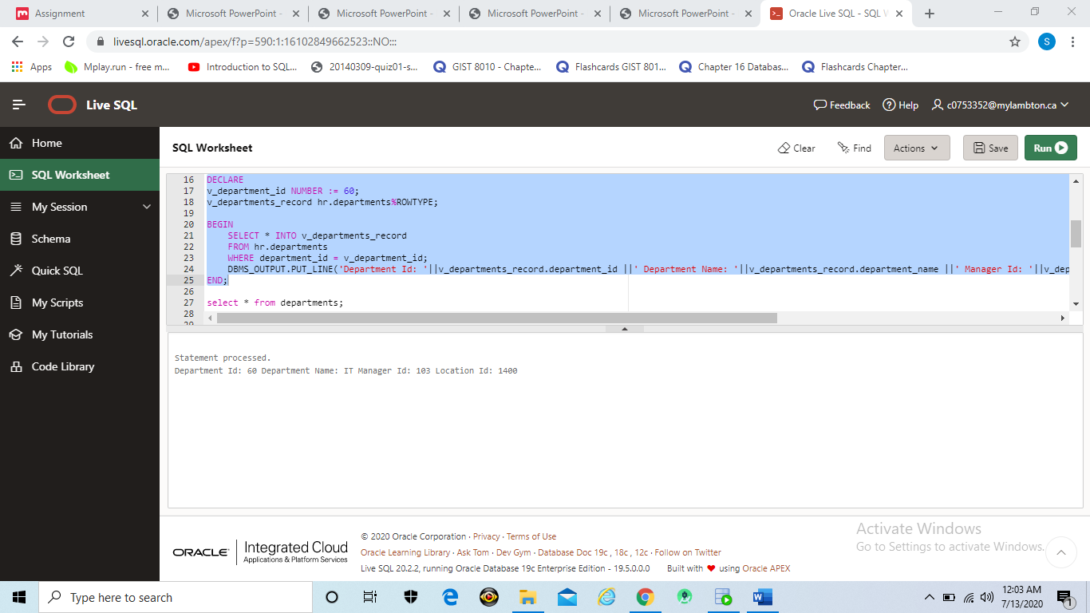

Exercise 11 (1.2%)

**Instruction: Include FULL PAGE screenshot that will display the code and the output on SQL Developer.**

Create a PL/SQL block to retrieve the names of some departments from the departments table and print each department name on the screen, incorporating an associative array.

1. Declare an INDEXBY table dept_table_type of type departments.department_name. Declare a variable my_dept_table of type dept_table_type to temporarily store the names of the departments.
2. Declare two variables: f_loop_count and v_deptno of type NUMBER. Assign 10 to f_loop_count and 0 to v_deptno.
3. Using a loop, retrieve the names of 10 departments and store the names in the associative array. Start with department_id 10. Increase v_deptno by 10 for every loop iteration. The following table shows the department_id for which you should retrieve the department_name.

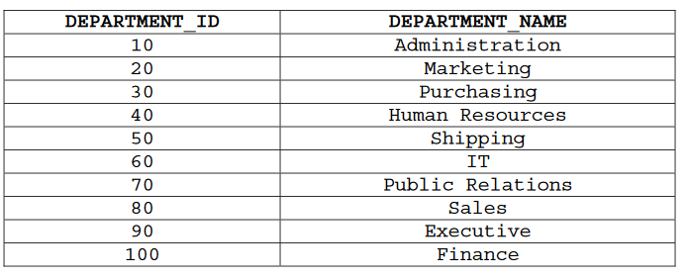

SET SERVEROUTPUT ON

DECLARE

TYPE dept_table_type IS TABLE OF departments%ROWTYPE INDEX BY PLS_INTEGER;

my_dept_table dept_table_type;

f_loop_count NUMBER (2):= 10;

v_deptno NUMBER (4) := 0;

BEGIN

for i IN 1..f_loop_count LOOP

v_deptno := v_deptno + 10;

SELECT * INTO my_dept_table(i) FROM departments WHERE department_id = v_deptno;

END LOOP;

DBMS_OUTPUT.PUT_LINE('DEPARTMENT_ID ' || ' DEPARTMENT_NAME');

for i in 1..f_loop_count LOOP

DBMS_OUTPUT.PUT_LINE (my_dept_table(i).department_id|| ' '||my_dept_table(i).department_name);

END LOOP;

END;

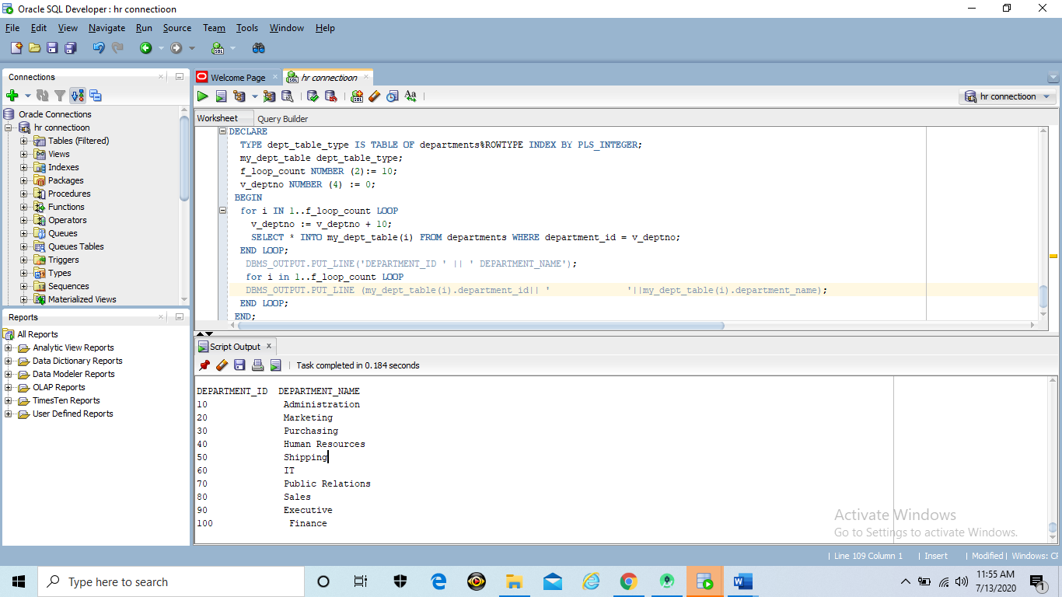

1. Using another loop, retrieve the department names from the associative array and display them.

The output will look like below table:

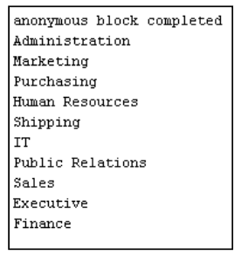

SET SERVEROUTPUT ON

DECLARE

TYPE dept_table_type IS TABLE OF hr.departments.department_name%TYPE INDEX BY PLS_INTEGER;

my_dept_table dept_table_type;

f_loop_count NUMBER := 10;

v_deptno NUMBER := 0;

BEGIN

for i IN 1..f_loop_count LOOP

v_deptno := v_deptno + 10;

SELECT department_name INTO my_dept_table(i) FROM hr.departments WHERE department_id = v_deptno;

END LOOP;

for i in 1..f_loop_count LOOP

DBMS_OUTPUT.PUT_LINE(my_dept_table(i));

END LOOP;

END;

